Assignment 2 – SQL Queries

Name: Vihaar Reddy

SECTION-A
Q1
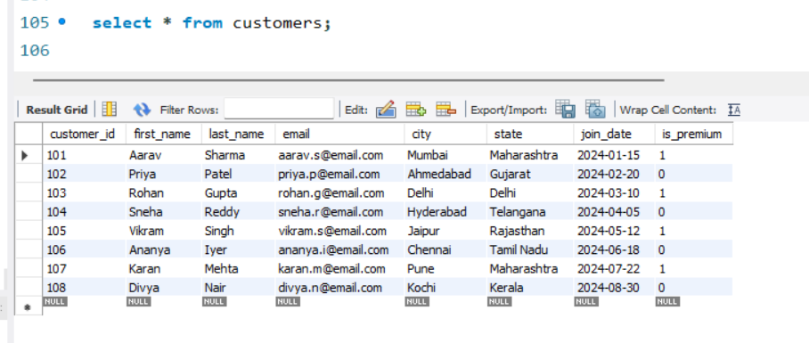

Q2
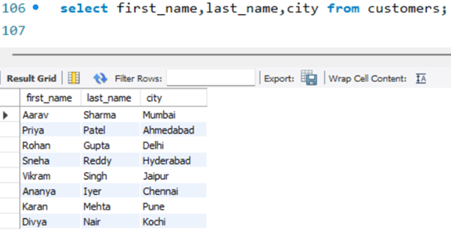

Q3
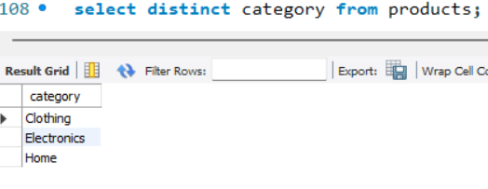
4:Answer
The primary keys in the given schema are:
- Customers → customer_id
- Products → product_id
- Orders → order_id
- Order_Items → item_id
A primary key is used to uniquely identify each record in a table. Since every row should represent a different entity, the primary key values cannot be repeated. This is why a primary key must be unique.
A primary key also cannot contain NULL values because every record needs a valid identifier. If a primary key were NULL, it would not be possible to uniquely identify that particular row, which would affect data integrity and relationships between tables.

5
The email column has the following constraints:
- UNIQUE – ensures that no two customers can have the same email address.
- NOT NULL – ensures that an email value must be provided for every customer.
If an attempt is made to insert a customer record with an email address that already exists in the table, the database will not allow the insertion. An error will be generated because the UNIQUE constraint is violated.

6
INSERT INTO products (product_id, product_name, unit_price)
VALUES (101, 'Keyboard', -50);
This insertion will fail because the table has a CHECK constraint that requires the unit_price to be greater than 0.
CHECK (unit_price > 0)
Since -50 does not satisfy this condition, the database rejects the record and returns an error.

7
INSERT INTO customers VALUES
(120, 'Vihaar', 'Reddy', 'aarav.s@email.com', 'Hyderabad', 'Telangana', '2025-01-15', TRUE);
0 | 23 | 09:56:38 | INSERT INTO customers VALUES (120, 'Vihaar', 'Reddy', 'aarav.s@email.com', 'Hyderabad', 'Telangana', '2025-01-15', TRUE) | Error Code: 1062. Duplicate entry 'aarav.s@email.com' for key 'customers.email' | 0.000 sec

8
0 | 25 | 09:58:22 | Insert into products values(200, 'oneplus buds','Electronics', 'BoAt',-50, 250) | Error Code: 3819. Check constraint 'products_chk_1' is violated. | 0.000 sec

9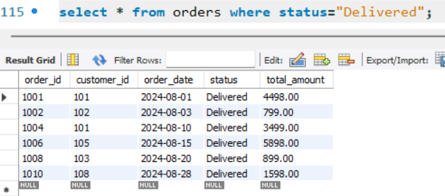

10
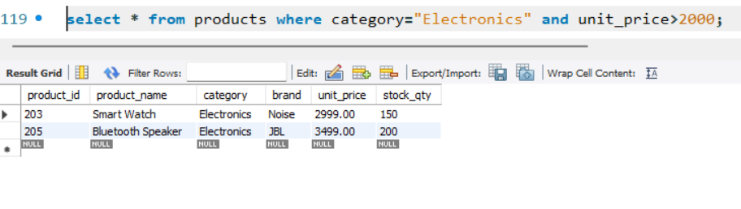
11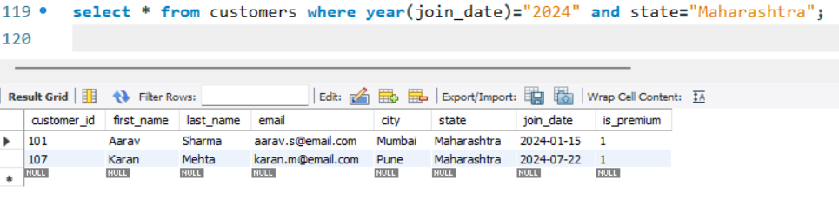
12
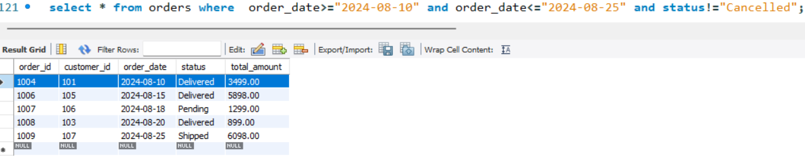
13
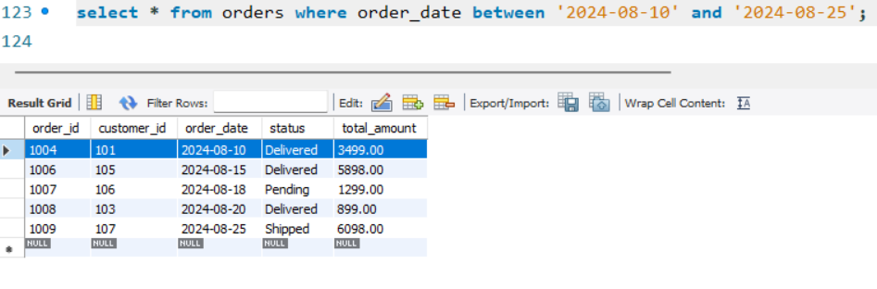

14
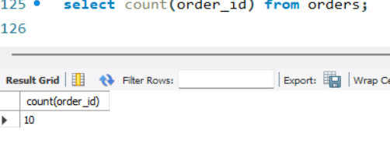
15
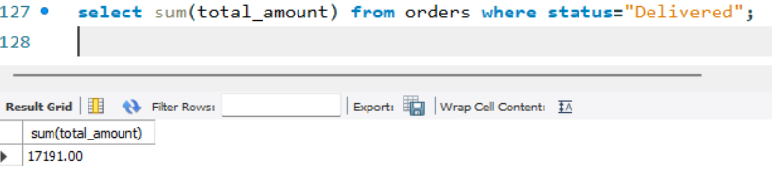
16
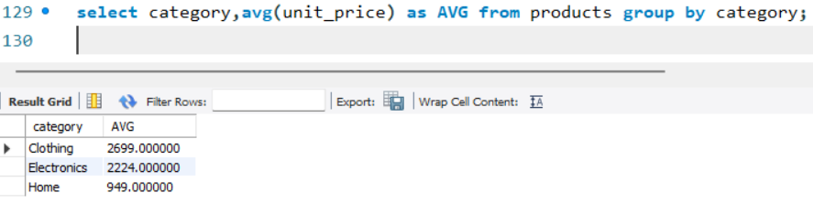
17
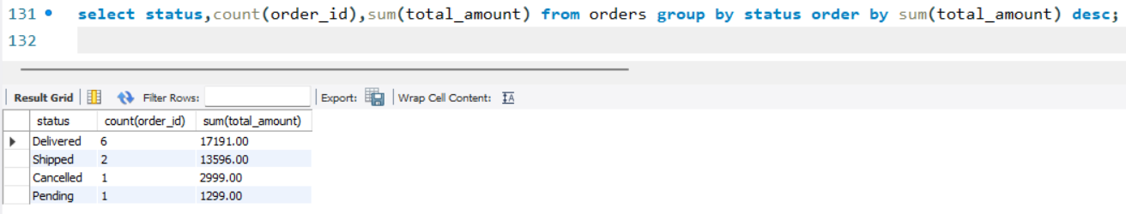

18
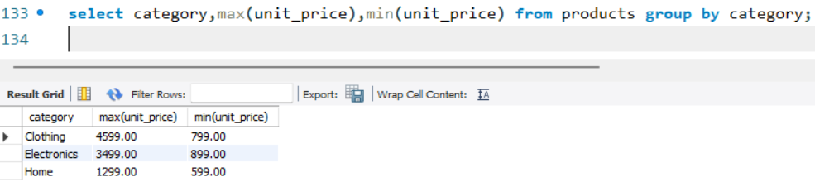
19
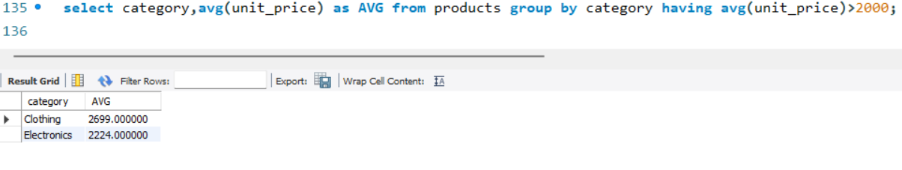
20 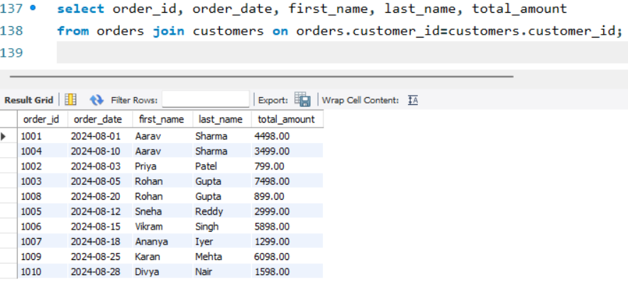21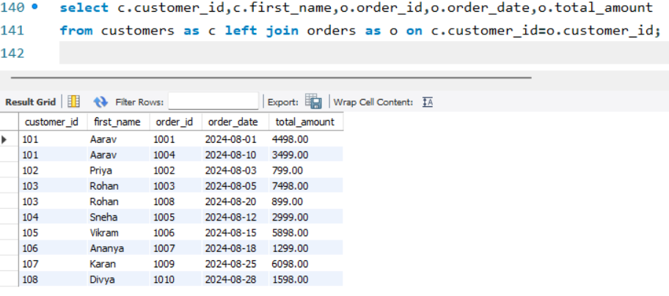
22 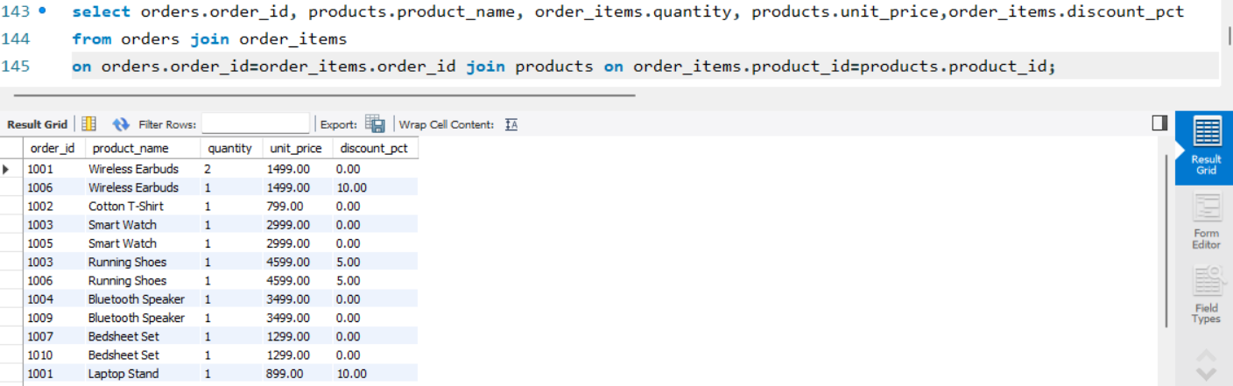
23
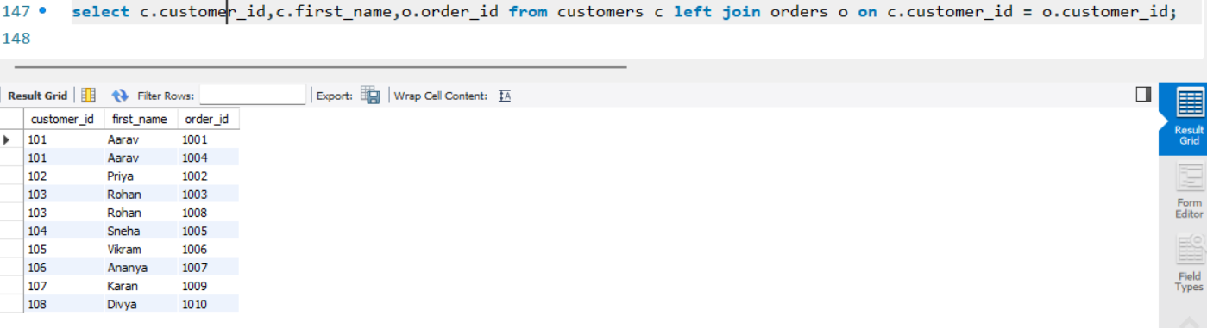

24
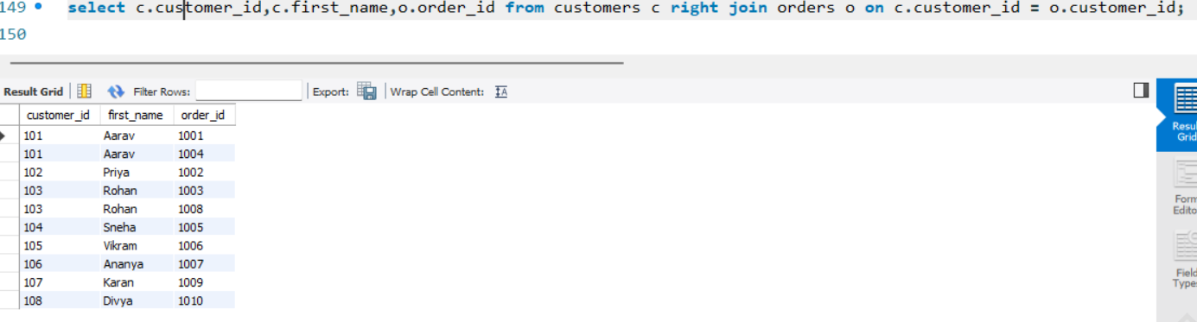
25 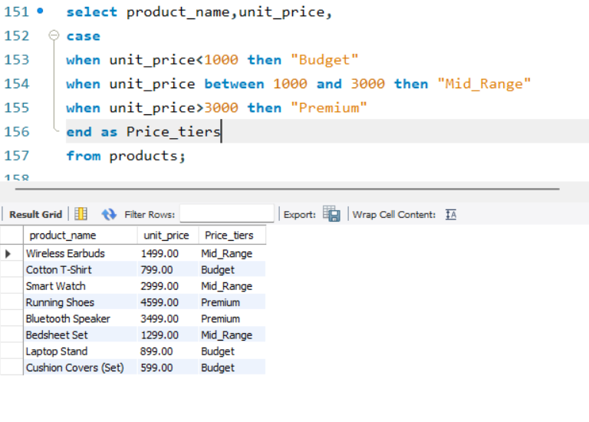
26
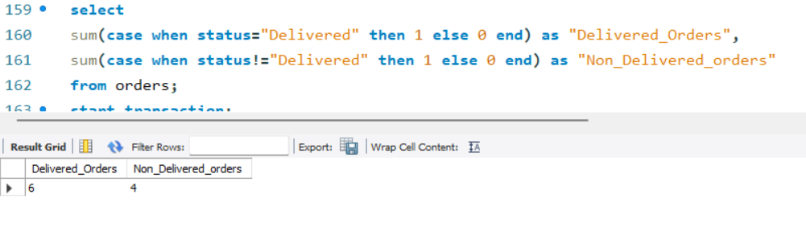
27
